PROJECT FLOW:

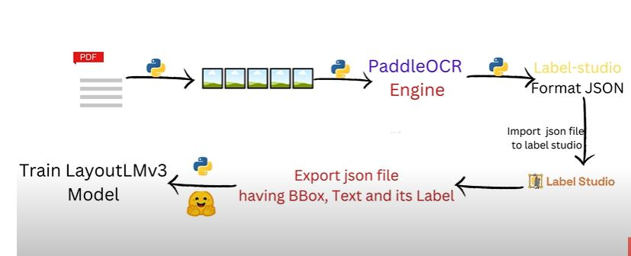

Convert pdf to image first:(enhance image quality)
—---------------------------------- Code here —---------------------------------------------------

import os
from pdf2image import convert_from_path
from PIL import Image,ImageOps,ImageFilter,ImageEnhance
import numpy as np
import cv2

def folder_creation(directory):
if not os.path.exists(directory):
os.makedirs(directory)

def rotate_image(image):
rotated_image = image.transpose(Image.ROTATE_90)
return rotated_image

def enhance_and_preprocess_image_advanced(image):

# Enhance contrast
enhanced = ImageOps.autocontrast(image)

# Convert to grayscale
grayscale = enhanced.convert('L')

# Apply Gaussian blur with a slightly adjusted radius
blurred = grayscale.filter(ImageFilter.GaussianBlur(radius=2.05)) # Slightly increased radius

# Enhance edges to highlight text and table boundaries
edges = blurred.filter(ImageFilter.FIND_EDGES)

# Increase contrast to make text and lines clearer
contrast_enhancer = ImageEnhance.Contrast(edges)
edges = contrast_enhancer.enhance(3.0) # Increased contrast for better edge visibility

# Further increase contrast of the original grayscale image
high_contrast = ImageEnhance.Contrast(grayscale).enhance(5.0) # Increased contrast

# Increase sharpness
sharpener = ImageEnhance.Sharpness(high_contrast)
high_contrast = sharpener.enhance(7.0) # Increased sharpness

# Convert images to NumPy arrays for OpenCV operations
high_contrast_np = np.array(high_contrast)
edges_np = np.array(edges)

# Apply adaptive thresholding
_, thresh_high_contrast = cv2.threshold(high_contrast_np, 128, 255, cv2.THRESH_BINARY)
_, thresh_edges = cv2.threshold(edges_np, 128, 255, cv2.THRESH_BINARY)

# Apply dilation and erosion to enhance lines and text
kernel = np.ones((1,1), np.uint8)
dilated = cv2.dilate(thresh_high_contrast, kernel, iterations=1)
eroded = cv2.erode(dilated, kernel, iterations=1)

# Convert processed image back to PIL format
processed_image = Image.fromarray(eroded)

# Composite edges onto the high contrast grayscale image
composite = Image.blend(processed_image.convert('RGB'), Image.fromarray(edges_np).convert('RGB'), alpha=0.2)

# Convert composite image back to RGB color mode
result_image = composite.convert('RGB')

return result_image

def pdf_to_image_from_folder(pdf_folder, output_image_dir):
# Ensure the output directory exists
folder_creation(output_image_dir)

# Iterate over all PDF files in the pdf_folder
for pdf_file in os.listdir(pdf_folder):
if pdf_file.lower().endswith('.pdf'):
pdf_path = os.path.join(pdf_folder, pdf_file)
# Extract images from PDF at 300 DPI
images = convert_from_path(pdf_path, 300)

# Process each image
for i, image in enumerate(images):
image = rotate_image(image)
image = enhance_and_preprocess_image_advanced(image)
image_filename = f"{os.path.splitext(os.path.basename(pdf_file))[0]}{i+1}.jpg"
image_path = os.path.join(output_image_dir, image_filename)
# Save the processed image
image.save(image_path, 'JPEG')

# Example usage
pdf_folder = './PdfFiles'
output_image_dir = './output_image_dir'
pdf_to_image_from_folder(pdf_folder, output_image_dir)
—---------------------------------- Code here —---------------------------------------------------

PPOCRLabel Studio ➖

PPOCRLabelv2 is a semi-automatic graphic annotation tool suitable for OCR field, with built-in PP-OCR model to automatically detect and re-recognize data. It is written in Python3 and PyQT5, supporting rectangular box, table, irregular text and key information annotation modes. Annotations can be directly used for the training of PP-OCR detection and recognition models.

—---------------------------------- Syntax —---------------------------------------------------

#Download tool for table recognition image annotations

! pip install PPOCRLabel # install

# Select label mode and run

>>PPOCRLabel

# Change the directory to the PPOCRLabel folder
>>cd ./PPOCRLabel

# create notation of images train,test,val image dataset
>> python gen_ocr_train_val_test.py --trainValTestRatio 6:2:2 --datasetRootPath ../train_data

—---------------------------------- Syntax —---------------------------------------------------

PaddleOCR ➕

Awesome multilingual OCR toolkits based on PaddlePaddle (practical ultra lightweight OCR system, support 80+ languages recognition, provide data annotation and synthesis tools, support training and deployment among server, mobile, embedded and IoT devices).

# Install PaddlePaddle

! pip3 install "paddleocr>=2.6.0.3"

PP-Structure:
PP-Structure is an intelligent document analysis system developed by the PaddleOCR team, which aims to help developers better complete tasks related to document understanding such as layout analysis and table recognition.

The main features of PP-StructureV2 are as follows:
- Support layout analysis of documents in the form of images/pdfs, which can be divided into areas such as text, titles, tables, figures, formulas, etc.
- Support common Chinese and English table detection tasks.
- Support structured table recognition, and output the final result to Excel file.

If you want to use the English table recognition model, you need to download the English text detection and recognition model and the English table recognition model in link: models_list

Training, Evaluation and Inference

1) The training, evaluation and inference process of the text detection model can be referred to link : detection
Link ( text detection model):
https://github.com/PaddlePaddle/PaddleOCR/blob/main/doc/doc_en/detection_en.md

Here we are using MobileNet_V3_Large backend for the detector

Previous model weights
!wget -P ./ https://paddleocr.bj.bcebos.com/pretrained/MobileNetV3_large_x0_5_pretrained.pdparams

—---------------------------------- for det images —---------------------------------------------------
python tools/train.py -c configs/det/det_mv3_db.yml -o Global.pretrained_model=./pretrain_models/MobileNetV3_large_x0_5_pretrained

—---------------------------------- for det images —---------------------------------------------------

2) The training, evaluation and inference process of the text recognition model can be referred to link : recognition
Link ( text recognition model):
https://github.com/PaddlePaddle/PaddleOCR/blob/main/doc/doc_en/recognition_en.md

Here we are using the latest PP-OCR-V3 model for the recognizer respectively.
Previous model weights
wget -P ./ https://paddleocr.bj.bcebos.com/PP-OCRv3/english/en_PP-OCRv3_rec_train.tar

—---------------------------------- for rec images —---------------------------------------------------
python tools/train.py -c configs/rec/PP-OCRv3/en_PP-OCRv3_rec.yml

—----------------------------------for rec images —---------------------------------------------------

3)The training, evaluation and inference process of the table recognition model can be referred to link : table_recognition

Link ( table recognition model):
https://github.com/PaddlePaddle/PaddleOCR/blob/main/doc/doc_en/table_recognition_en.md

—---------------------------------- for table model images —-------------------------------------
python tools/train.py -c configs/table/SLANet.yml
—----------------------------------for table model images —----------------------------------------

